**GEOS3102: Global Energy & Resources Labs**

Dietmar Muller, Tristan Salles, Amy I’Anson

Lab Overview

|  |  |  |  |  |
| --- | --- | --- | --- | --- |
|  | **Exercises** | **Weight** | **Due Date** | **Submission** |
| Lab 1 (Week 8) | Intro to Global Petroleum Resources and iPython | 10% | Thursday May 11 @ 9am | Madsen Dropbox |
| Lab 2  (Week 9) | Badlands | 15% | Thursday May 18 @ 9am | Madsen Dropbox |
| Lab 3 (Week 10) | Seismic Reflection Surveys | 15% | Thursday May 25 @ 9am | Madsen Dropbox |
| Lab 4 (Week 11) | Well Log Analysis | 15% | Thursday June 1 @ 9am | Madsen Dropbox |
| Lab 5  (Week 12) | Arafura Basin Petroleum Systems | 15% | Thursday June 8 @ 9am | Madsen Dropbox |
| Lab 6  (Week 13) | Tectonic Subsidence and Arafura Basin Report | 30% | Thursday June 15 @ 9am | Email [amy.ianson@sydney.edu.au](mailto:amy.ianson@sydney.edu.au) |

Each week a paper copy of the exercise will be provided for you. Please write neatly and clearly, messy and illegible reports will not be marked. You are also welcome to complete the exercise in the pdf available online. Remember to attach relevant maps and data.

Exercises are shown in grey boxes, answer in the space provided or attach your answer to the lab sheet.

**Your assignment is due Thursday the following week at 9am! 10% will be deducted per day late.**

Please note: You do not need to include your script for iPython practicals unless a question states “**Include your script”** in which case you only need to include the relevant portion of your script (please do not waste paper and print the entire script).

Lab 2: Badlands - Surface Processes and Sea Level

The Sedimentary Record of Sea-Level Change is about how we can detect past changes in sea- level from an analysis of the sedimentary record. Sequence stratigraphy incorporates two long-standing observations: first, that the sedimentary record shows repetitions or cycles; and secondly, that some sedimentary units can be traced over long distances.

The sequence can be divided by surfaces systems tracts. Each systems tract is represented by a collection of the sediments of the associated sedimentary depositional systems that were active during the different phases of base level change. Thus systems tract sediments can be considered as sedimentary units that were deposited synchronously and can be mapped as being enclosed by continuous surfaces that extend from sub-aerial and to sub-aqueous settings.

The sequences of the sedimentary record are generated by cycles of change in accommodation and/or sediment supply that also form similar sequence stratigraphic surfaces through geologic time. cycles may be symmetrical or asymmetrical, and may or may not contain the systems tracts of a fully developed sequence. A function of scale, sequences and their bounding surfaces may have different hierarchical orders recording a series of geological events, and processes in sedimentary rocks that form a relatively conformable succession of genetically related strata. Their upper surfaces and bases are bounded by unconformities and their correlative conformities (Vail, et al., 1977). A sequence is formed by a succession of genetically linked deposition systems (systems tracts) interpreted to have accumulated between eustatic-fall inflection points (Posamentier, et al., 1988). The sequences and enclosed system tracts are subdivided and/or bounded by a variety of "key" surfaces that bound or envelop them. As described above these include sequence boundaries (SB), the basal surfaces of falling stage systems tracts (BSFSST), transgressive surfaces (TS) and a maximum flooding surfaces (mfs). These erosional and depositional surfaces mark changes in depositional regime or "thresholds" across that boundary.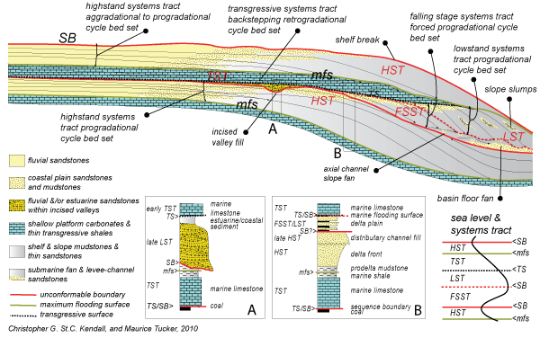

If you are unfamiliar with the key terms of sequence stratigraphy here is a great resource - <http://www.sepmstrata.org/page.aspx?&pageid=15&3>

In this lab we will analyse the influence of sea-level fluctuations on the development of stratigraphic sequences in deltaic environments, based on the results from a surface process model (badlands).

Basin and Landscape Dynamics (Badlands) is a parallel TIN-based landscape evolution model, built to simulate topography development at various space and time scales. The model is capable of simulating hillslope processes, fluvial incision (erosion/transport/deposition), spatially and temporally varying geodynamic (3D displacements) and climatic forces which can be used to simulate changes in base level, as well as effects of climate changes or sea-level fluctuations.

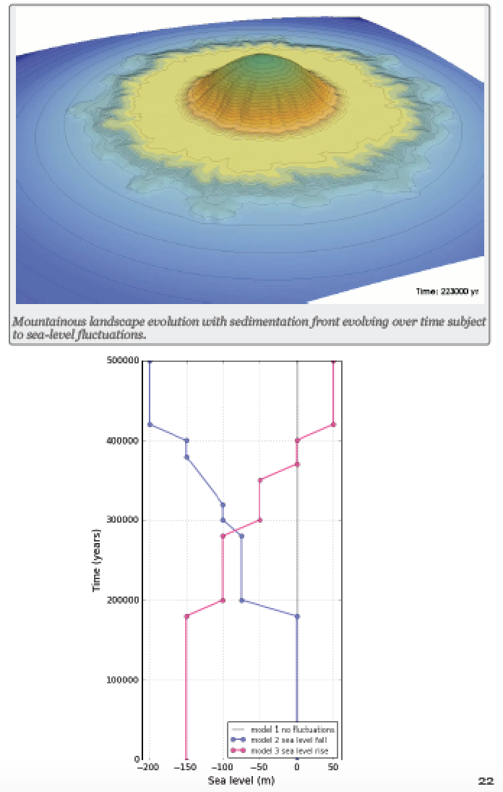Model Conditions

Four different models with varying sea-level inputs have been ran with Badlands. You will use IPython to analyse and interpret the results of these models. Badlands model simulates the erosion, transport and deposition of sediments by rain under geological time scale. For the 4 models that we are going to analyse the initial surface represents a mount which is a half ellipsoid of 2000 m height and about 8 km large. An uniform precipitation rate of 1 m/yr is applied on the all area and the evolution of the surface is due to both hillslopes and overland flows. Two hillslope coefficient are defined for both the aerial and marine area.

The simulation runs for 500,000 years and for each models we impose different sea-level condition through time (values are defined in the plot on next page for the first 3 models).

In a nutshell, the first model simulates the erosion of the mount and the development of prograding deltas under a constant sea-level. For the second model, we impose in 5 steps a sea-level fall from 0 to -200m. For the third model, the sealevel rise from -150 to 50 m in 5 steps as well.

Lab 2: Exercises

**NAME: _________________________________ SID: ________________________________**

The last step of the 4 models (after 500,000 years) have been uploaded on the IPython server. The output produced by Badlands are hdf5 files and we will need to open them in IPython before processing the dataset further. Open the notebook and follow the different steps required to extract the stratigraphic layers for the final time steps along the X-axis.

Q1. Plot all 4 models, label the axes and give your figures headings. **Include these figures as an appendix to your lab report.**

Q2. Explain the difference between Model 1, 2 and 3 in terms of sea level fluctuations and stratigraphic sequences. Be sure to use appropriate terminology.

____________________________________________________________________________________________________________________________________________________________________________________________________________________________________________________________________________________________________________________________________________________________________________________________________________________________________________________________________________________________________________________________________________________________________________________________________________________________________________________________________________________________________________________________________________________________________________________________________________________________________________________

Q3. Explain the difference between progradational and retrogradational stacking. Which models could your associate with these geometries?

______________________________________________________________________________________________________________________________________________________________________________________________________________________________________________________________________________________________________________________________________________________________________________________________________________________________________________________________________________________________________________________________________________________________________________________________________________________________________________________________________________________________________________________________________________________________________________________________________________________________________________________________________________________________________________________________________

Q4. Describe the geometry of Model 4. On this model, can you show potential erosional surfaces based on the stratal geometries?

______________________________________________________________________________________________________________________________________________________________________________________________________________________________________________________________________________________________________________________________________________________________________________________________________________________________________________________________________________________________________________________________________________________________________________________________

Q5. Give a possible sea-level fluctuation scenario which could produce a similar stratal pattern to Model 4. Explain

______________________________________________________________________________________________________________________________________________________________________________________________________________________________________________________________________________________________________________________________________________________________________________________________________________________________________________________________________________________________________________________________________________________________________________________________